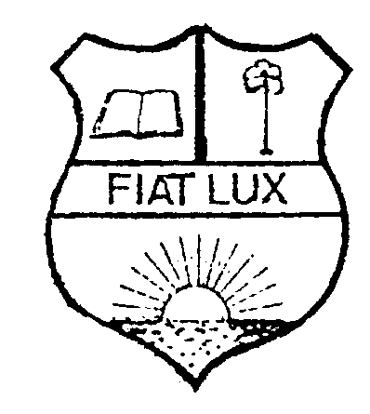
HARTLEY NEWS – VICTORIA

A newsletter from Hartley College (Point Pedro) Past Pupils Association
Victoria Branch, Australia Issue No.8, July 2002

Annual Family Get -together and Cricket Match

The Annual Family Get-together and Cricket Match took place on 3rd February 2002 at Mount View Primary School, Glen Waverley. Though arrival of members was slow at the beginning, about 40 members and their families turned up for the occasion. Some sportive members and their children participated in the cricket match.

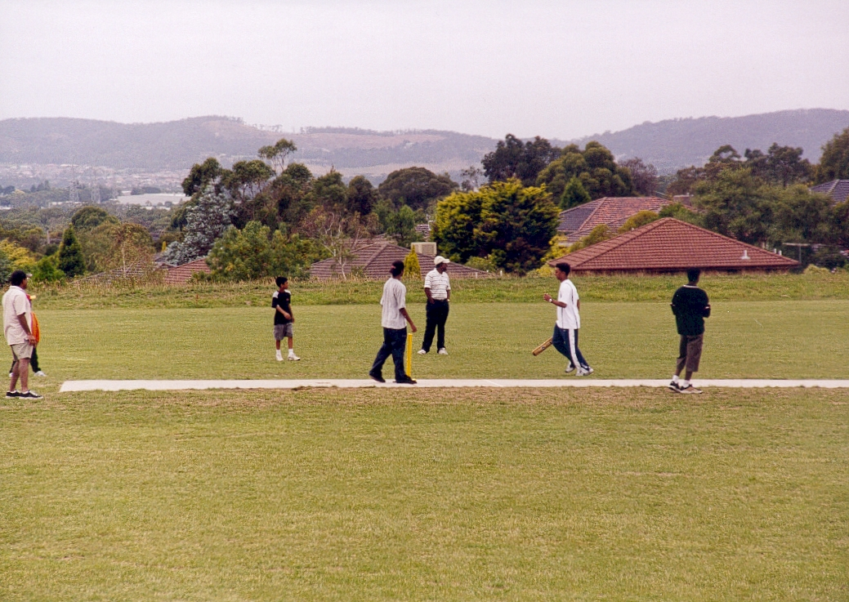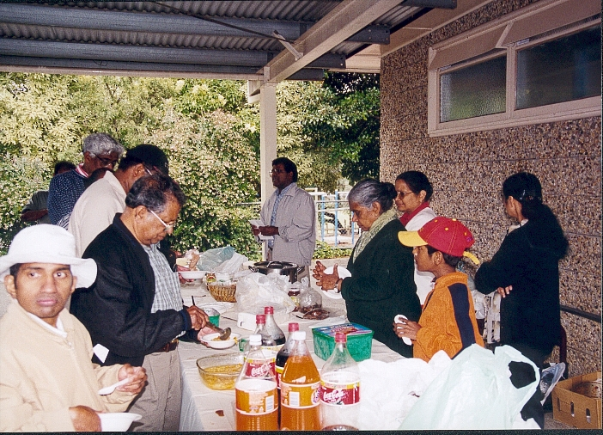

Members and children playing cricket The President giving vote of thanks

Everyone was with great enthusiasm and in high spirits. The gathering ended with our traditional rice and curry lunch and vote of thanks from the president.

FORTHCOMING EVENT - Annual General Meeting and Dinner

The Annual General Meeting will be held on Saturday, 17 August 2002 at the Highvale Primary School, Glen Waverley.
It is an opportunity for the members to express their views in the AGM and to render their service to the association by joining the committee.

Joint Meeting of HCPPA branches around the world on 28th July 2002

A joint meeting of all branches of Hartley College Past Pupils Associations around the globe will be held in Colombo to make an effort to stream line the financial inputs from various branches so that

- The finances are spent for the purpose for which it was intended and there should be accountability for the money spent.
- Each branch to know what other branch is doing and to avoid duplication
- To agree on a unified plan for a fitting program to remember the late Mr. Pooranampillai.
- To discuss and agree on matters pertaining to the school such as the present occupation of the school by the Army and the possibility of rash actions by authorities to tamper with historical landmarks and names of houses etc.
- Discuss and outline an action plan to meet the challenges of shortage of teachers and or inadequacy of teachers and making use of modern technology to supplement such shortcomings.
- Future plans of help to the school in fields identified by the Principal of the school.

Venue: Hotel Galadari, Date: Sunday 28th July, 2002, Time: 9:00 a.m to 9:00 p.m

Delegates: Australia, NSW & Victoria: Mr. P. Elango
Canada &USA : Dr. A. Shanmugavadivel, Mr. S. Krishnalingam
United Kingdom: Mr. R. Ravindralingam and Easwaramohan
Colombo: Mr. V. Jeyarajah, Mr. M. Ravindrakumar, Mr. V. Balasundaran, Mr. Mahadevan,
Dr. J.N.Chinniah, Mr. Chella Pathmanthan, Mr. S. Balachandran, Mr. Shanmuganathan,
Mr. T. Ragunathan, Mr. K.B.Rajalingam
Point Pedro: Mr. Nadarajasundaram, Mr. Selvarajan,
School Principal: Mr. Sripathy

Coordinator: Mr. M. Atputhanathan (Canada &USA branch, e-mail ‘atput@interlog.com' )

PRINCIPALS WHO SERVED HARTLEY (5)

W. N. S. Samuel (1975 – 1985)

In the last issue, a brief account of Mr. P. Ahamparam who was the Principal at the Hartley College from 1973 to 1975 was published. Mr. W. N. S SAMUEL succeeded him in 1975.

W. N. S Samuel came from Saththanai, Karaveddi. He was a Hartleyite and so did his father. After he completed his studies at Hartley, he joined the Jaffna College, Vaddukoddai, to prepare for the Arts Degree of London. His subjects were English, Tamil and History. On completing his degree, he taught for a while at Sacred Heart College, Karaveddi, and joined Hartley in 1953. He fitted into the life of the school quite easily, and was found to have a flair for guiding pupils with problems. Accordingly he was appointed as a “Counselor” to guide the pupils in regard to their studies and problems.

He served under the all-previous principals. When Ahamparam left to go to Africa, he became the principal. He was one of those who threw themselves into work so deeply. His period is notable for the erection of Thamotheram and Pooranampillai blocks and academic excellence.

Unfortunately for him, in his term of office, the Sri Lankan Army occupied the Pooranampillai Block and a number of classrooms and, some other classrooms and the library were damaged by fire. The loss of several classrooms, some used by the army, and some destroyed by the fire, necessitated the shifting of some classes to the Puttallai Maha Vithyalyam.

W. N. S had to retire at his minimum retirement age due to his family commitments. After retirement, he lived in Madras, India where he fell ill and died.

Two of his sons live in Australia, Kirupaharan in Melbourne and Vaseekaran in Perth.

A Visit to Point Pedro
by S.Parameswaran ( Former President of HPPCA – Victoria )

Since the start of the peace process in Sri Lanka, people have been visiting North East region from the other parts of Sri Lanka and overseas. I stayed in Point Pedro for 23 days starting on 11 June 2002. Arriving in Colombo on 4 June 2002, I had to wait for almost a week to get a seat in one of the flights between Ratmalana and Palaly. At the time, there was only one flight per day from Monday to Saturday but no flight on a Sunday. Aviation Expo Ltd using an aircraft having over 100 seats operates the flights. Even though the flying time is only 50 minutes, it took about 7 hours to reach Manthikai from Wellawatte via Jaffna. After collecting our bags at Palaly, we were brought to Jaffna by bus under the surveillance of the army. In Jaffna I hired a car to complete my journey. The total cost of this trip was Rs 4,025, including Rs 850 for the car hire.

The President and the Secretary of HCPPA (Victoria Branch) requested me to obtain some information from the HCPPA, Point Pedro. Following my discussions with the joint Secretary, Mr. Selvarajah, I was invited to attend a committee meeting to be held at the Principal’s Office on 30 June 2002. The meeting gave me an opportunity to visit the College that had a restricted access.

The only access to the College is through Arthiaddy Road. To the south of the College Road and the Old Police Station Road junction, there is an army checkpoint where the identity of each person is checked. When I passed through the checkpoint with Mr. Selvarajah to attend the meeting, the army officers were polite and friendly.

I saw the rear of the College occupied by the army and the Principal’s Office relocated to the ground floor of the 3 storey Professor Thurairajah Block built by demolishing the old laboratory. The old Assembly Hall, which was parallel to the old laboratory, has been replaced with a single storey block with provision for another two storeys. Another 2 blocks are to be constructed in the north / south direction to form a rectangular shape. The centre of the rectangle is almost that of the old Tennis Court. There is a new canteen that is run by the HCPPA Parent Body. The hostel building has no roof.

At the committee meeting presided by Mr. Nadarajasunderam, I was briefed on the activities funded by our Branch. Part of the funds for the sports and library has been utilised to purchase cricket items and books. The 2001 bursaries and prizes have been awarded as follows:
Melbourne Bursary award of Rs. 6,000: K. Navarubathas (k. nvYRptasf) and Y. Thineshkumar (Eya. tiE[sfKmaaf).
Professor Eliezer Mathematics award of Rs. 2,500: K. Vishnukanthan (k. vixf}kanft[f) and S. Jenahan (c. ej[k[f).

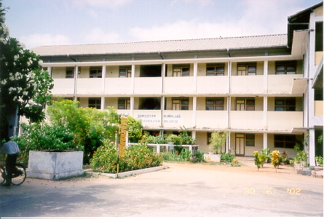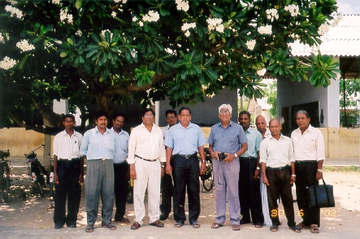

Professor Thurairajah Block Mr. Parameswaran with members of the Parent Body
Every year, the HCPPA (Parent Body) presents medals in one of its committee meetings to those students who obtain 3 As in the G.C.E (Advanced Level). The 2001 medals were presented at the meeting that I attended. This year, only 2 students qualified for medals. As requested by the President, Mr Santhalingam from the UK and I presented the medals to Messrs R.Gajanathan and R. Vaikunthavasam respectively.

One of the students who will be offered a place at the University needs financial help for four years to complete his studies. The Committee asked me to find out whether the Victoria Branch would be in a position to render some form of assistance to him.

The College now has 11 computers, seven donated by the Prime Minister, Ranil Wickramasinghe and three from the HCPPA (UK Branch). The question of employing a teacher is yet to be resolved.

Overall, my trip to Point Pedro was successful and I look forward to making another trip perhaps next year.

Sri Lankan Prime Minister visits Hartley College

According to The Island (17th & 18th March, 2002) News Paper, Sri Lankan Prime Minister Ranil Wickremesinghe wound up his two-day visit to Jaffna on Friday the 15th March 2002.

Earlier in the day the students of Hartley College, Point Pedro, accorded Prime Minister Wickremesinghe a warm welcome. He was showered with flowers and hailed as the ‘great philosopher, the scholar, the spiritual leader, the treasure-house of wisdom, and prince of peace’.

Addressing them the PM said that education, which is dear to the hearts of the people of Jaffna, had suffered due to the ongoing conflict. He added that it could be elevated to its past glory with the achievement of a durable peace.

He pledged to gift computers to all the main schools in the peninsula and made a token presentation of four computers to Hartley College.

SLA Vacates Hartley College

The Sri Lanka Army has been occupying the school’s premises since 1997. The schooling has been disrupted by the soldiers’ presence. Students and teachers have to enter and leave through checkpoints that the army has set up at the entrances of Hartley College and the Pt. Pedro Methodist Girls College.

Students of Hartley College and the Pt. Pedro Methodist Girls College held mass demonstration, picketing and boycott of classes on May 23 demanding the immediate removal of SLA camps from their schools. Another demonstration was held in June.
According to the HCCPA - Colombo branch, Sri Lanka Army will be vacating the school premises on 2nd August 2002.

Hartley Principal gets transfer

According to the HCCPA - Colombo branch, the present Principal Mr. Sripathy, an old student of Hartley, will be transferred to the Education Department from 1st August, 2002.

Our web address

www.hartleycollege.org -> HCCPAs/OBAs -> Victoria Branch

Hartley College History

The Hartley College web team is in the process of compiling the history of our school over the last decades. In this process it has created a web-based tool to collect the information electronically via Internet.

The web team welcomes you and all the Hartleyites around the world to provide it with your memories to build up the history of Hartley College.

You may submit your entry by visiting the following link: http://www.HartleyCollege.org/hweb/history/

New addition to the Hartleyites' Family Tree

Logetha was born on 19th February 2002 to Mr. and Mrs. Nandakumaran , who is our current Treasurer.

The "In Memoriam" Gathering of Emeritus Prof. C. J Eliezer

It was held on 21st April 2002 at the Mulgrave Community Centre, Mr. K. Anandaganeshan, Mr. M. Shanthikumar and Mr. S. Parameswaran attended on behalf of HCPPA – Victoria.

Book Donation

Mrs Rani Eliezer has donated 6 to 8 Maths books of Late professor Eliezer to Hartley College library. These books have to be delivered to Point Pedro from Melbourne.

Members who are planning to travel either to Colombo or Point Pedro and willing to take those books with them, please contact Shanthi Kumar on 8802 7785 to make the arrangements. The Committee sincerely thanks Mrs Rani Eliezer for the kind and the thoughtful donation, which will be very much appreciated by the students of Hartley.

n[fbi nvillf
vIrEkcai, 3. 3. 2002f

uyaftiR. Ci[f[tftmfpi mEknftir[f (c[atipti cdfdtftr]i)
mAbnft c[atipti cdfdtftr]i ci[f[tftmfpi mEknftir[f KDmfptfti[af, `[f[aai[f mAbv<kfK ;Bti `wfcli ecLtftiyvafkQkfKmf, `{tapcf ecyfti `{pfpiyvafkQkfKmf, mlaf `wfcli ecLtftiyvafkQkfKmf, ;lgfAk cdfdtftr]i cgfktfti[RkfKmf, hadfli klfL\ai pAzy ma]vaf (ekaZmfp< kiAq) cgfktfti[RkfKmf, ;Bticf cdgfKkqf etadafpak pl vzikqilf utvi ecyft `A[vRkfKmf m[maafnft n[fbiAytf etaivitfTkfekaqfki[fb[af. t[ipfpdfd vAkyilf ovfevaRvafkfKmf n[fbi ecLtft MFyaAm KbitfT vRtfttftiA[y<mf etaivikfki[fb[af.

eclfvi pirmiqa mEknftir[f KDmfptfti[af,
34, Collingwood Place, Colombo – 06

Acknowledgements

The assistance provided by Vice President Mr. M. Shanthikumar, Former President S. Parameswaran, the Member Mr. N. S. Ganeshalingam and other committee members is acknowledged and appreciated.

Members are welcome to send any Hartley related news, which will be published if it is recent and has enough information.

Editor: K. Ranganathan

