Canadian Hartleyite
Newsletter of the Past Pupils’ Association of Canada/USA | Vol 6, No 1, April 2002

United effort to Aid Hartley by HCPPAs around the Globe

Library subjected to Arson 1st Sept 1984

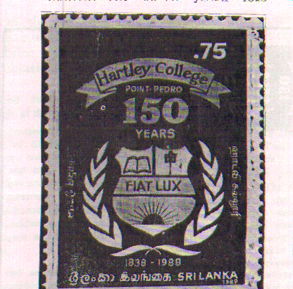
The Belfry of the College
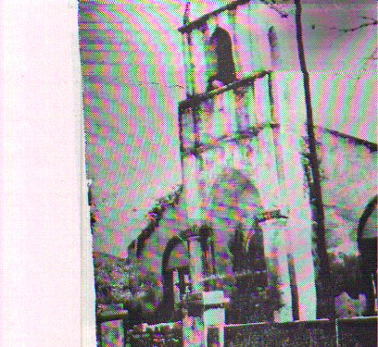

Issue of New stamp on 5th June1989

In this issue...

Kalai Vilza on May 11th at Mississauga 2
Update on Life Membership 2
Information on our Projects for Hartley 2
News from HCPPA Canada/USA 2
3
Extract from the Sri Lanka truce deal 4
1st year Remembrance of Prof Eliezer 4
Editorial 4

We bring to you the happy news that all branches of HCPPAs around the globe have tentatively agreed to meet in Colombo either during July or August this year under the auspices of Colombo branch to plan out a united effort to help Hartley to function normally and at the same time update some of its facilities in keeping with the modern technology.
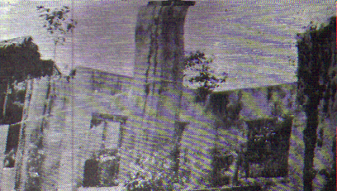

Quite a lot of suggestions as to what aspects should be taken up at this meeting, how the meeting should be planned to get the maximum outcome and the pre planning necessary, have been coming from the branches. We give below some highlights of the suggestions received from branches:

1.Major building projects and purchase of land to be left out for the moment.

2.Some of the projects identified are ; sports room , sports fund to supplement the facilities available at College, equipping the Library that has been built to replace the one burnt down, renovating and equipping the Laboratories, to develop Computer education, to provide supplementary facilities like telephone, internet, photocopying machine and supplementing furniture for class room.

3.It is the view of most branches that the Principal and the Parent body should prepare detail estimates for the meeting to consider, and Principal and the Parent body should be a key player at this meeting.

4. This meeting should also consider Mr. Pooranampillai memorial project.

5.Each branch could undertake one or more projects depending on their facilities and in the direction in which they are helping now and avoid duplication of effort.

6. A convener should be appointed to co-ordinate this meeting and to follow it up.

Discuss such administrative matters that are necessary to co ordinate efforts and uninterrupted flow of funds like the one existing in UK.

IF ANY OF YOU HAVE OTHER IDEAS PLEASE COMMUNICATE TO Mr. M. Atputhanathan (416 439 7696; e-mail “atput@interlog.com”
Dr. A. Shanmugavadivel(416 266 5161 e-mail “drashan@hotmail.com

Kalai Vilza on May 11th at Mississauga
The Annual Kalai Vilza has been fixed for Saturday May 11th at 6:00 p.m
The venue this time is Glen Forest Secondary School, 3575 Field Gate Drive, Mississauga. The direction for those coming from Toronto are given below. The tickets can be had from any of the committee members. Mr. Rajeswaran the convener is promising a spectacular evening that will be in your mind for a long time. Please keep the day free and come with your friend and family. In addition to young artists you will also meet TV personalities on the stage.
The proceeds from this Kalai Vilza will go towards the Fund we are raising to equip the newly built Library that has been built to replace the one burnt down by the forces.
Direction for Toronto residents

Take 401 to Dixie Rd. In Mississauga go south on Dixie Rd. To Burnhamthrope Rd.Turn Left on Burnhamthrope Rd to go east. Then turn right on Field Gate Drive.

Update on Life Membership
121.Mr. R. A. Iruthayanathan 859 273 83254 122. Mr S.Ramesh 905 612 0394 . 123. Mr. N. Muruganandan 416 695 3998 124. Mr.S. Thangarajah 416 439 9211 125. Mr. C. Jeyamohan 732 274 0536

Information about our Projects for Hartley
( Information received from president parent body, Mr. K. Nadarajasundaram)

ACADEMIC SCHOLARSHIP FUND
The following one time scholarship awards were made based on the Advanced Level results of 2001, awarded in March 2002. Each student received Rs 5000.00 each.
Scholarship in memory of late Mr. S.T.Samuel
Mr. Ravindran Gajanathan - Bio
Mr. S. Selvananthan - Arts
Scholarship in memory of late Mr. R.M.Gunaratnam
Mr. Ramalingam Ravindran - Maths
Scholarship in memory of late Mr. W.N.S.Samuel
Mr. Rajendran Vykunthavasan - Commerce
AWARDS FOR BEST SPORTSMAN OF THE YEAR
The following best sportsman of the year awards were given based on their 2001 performance in memory of late Mr. P. Ahamparam. Each award amounts to Rs. 3000.00.
Cricket: Mr. S. Kiretsan
Football: Mr. V. Muguntharajah
Athletics: Mr. V. Thinesh
Volly ball: not awarded
FOOTBALLER OF THE YEAR CHALLENGE SHIELD
This challenge shield donated by Mr. N. Sivapalan, Canada was awarded to Mr. V. Mugundarajah

LIBRARY FUND

The Library fund in the name of late Mr. K. Ratnasabapathy started by Canada/USA branch with a target of one million Sri Lankan rupees now stands around RS. 544, 500.00.
The interest received were used as follows:
Purchase of books in June and in December 2001 amounts to 36000.00.
Furniture purchased amounts to Rs 36 000.00

SPORTS FUND

Interest has been received from the Sports fund maintained by Canada, with Colombo PPA. All expenses met with this interest will be sent in due course.
( These information was received in two parts, one in Feb 2002 and another in March 2002)

News from HCPPA Canada/USA
PROGRAMME FOR THE YEAR 2002
Benefit show March 16th
Kalai Vilza May 11th
Cricket July 1st
Picnic either July 20th or 27th
Hartleyites Nite and AGM November 9th

MR.GANESHAN RAMACHANDRAN PASSES AWAY

Ganeshan, an old Hartleyite and a life member of HCPPA Canada/USA branch died of car accident on 7th of January 2002. He was 41 years old . He is survived by his wife, Janaki and children Krishni and Mayuran and his parents Mr & Mrs Ramachandran, who himself is an old Hartleyite and a life member.

Ganeshan studied at Hartley from 1972 to 1978. While at Hartley he excelled in cricket and Athletics, particularly Javelin. He competed in the All island under 17 and under 19 Athletics competition. He was an opening bowler and a good middle order batsman with a flair for hitting sixes. After leaving Hartley College he studied Marine Engineering in Sri Lanka and later graduated in UK. He came to Canada in 1990 and graduated as a stationary engineer and was working at St. Augustine seminary.

Large gathering of members were present at the viewing and Mr. Sivapalan gave the Eulogy and a wreath was placed by the Association

(Article by Mr. V. Jeyaraman, appeared in Hartley Web site)

MR.S.SANTHIRALINGAM’S ORBITUARY

Mr. S. Santhiralingam passes away following a heart attack at his residence in Scarborough Canada on 14th march 27, 2002. He is the son of late Mr. Sinnathurai former manager Central theater and founder member of United Sports Club Point pedro. After finishing GCE at Hartley in the sixties, he joined Inland Revenue Department of Sri Lanka. He leaves behind his wife Wijeyambihai, sons Santhirakanth Technical asst. Programmer University of Waterloo, Ashokanth, Consultant Rogers At &T and Premkanth

We express our deepest sympathy to his family

(Details given by Mr. K. Rajeswaran)

VANNI PROJECT AND FR. JEYAKUMAR’S NOTE

This is the third year Hartley College PPA Canada/USA is supporting 3 schools in Vanni District in giving those undernourished children one good square meal through the three schools. This project is done through HUDEC, a humanitarian project an organization run with the cooperation of Education department and religious bodies.
We are thankful to those members who promised to contribute. Some of them have sent in their contribution. We would appreciate if others too sent in their contribution to either Treasurer Mr. V. Jeyaraman ( 905 787 0136, e-mail “jvadivelu@aol.com”) or to asst. Treasurer Mr. K. rajaratnam (416 502 1423, e-mail “kuber@sprint.com”).
THERE ARE MANY OF YOU WHO COULD NOT BE PRESENT AT THE HARTLEYITE NITE WHEN THE CONTRIBUTIONS WERE RECEIVED. PLEASE CONTACT ANY OF THE OFFICIALS GIVEN ABOVE AND GIVE YOUR CONTRIBUTION. WE ARE EXPECTING A MINIMUM CONTRIBUTION OF $100.00 PER YEAR.
Fr, Jeyakumar co ordinator of the project sends us this message about the PEACE MARCH. “ Under the patronage of the Consortium for Human Agencies Jaffna (Comprising 47 organizations) along with four major religious organizations conducted a peace walk on the 23 of February 2002 commencing at St. Mary’s Church, Sinnamadhu in the island and proceeded 26.5 Km reaching Nallur Sivan temple at 5:00 p.m. En route the procession was welcomed and blessed by Fr. Jeyasegaram at St. James church, Gurunagar and Hindu Gurukal also spoke, Finally it ended up at the Historical Nallur Hindu Temple.
The following day The Peace walk left the Nallur Temple with the blessings of the four religious dignitaries reaching Thukaiamman temple at Tellipalai covering a distance of 13.5 Km in Valigamam North. Three to four thousand representing a cross section of the population along with religious dignitaries of all faiths emotionally participated.Simultaneously a peace march in support commenced at Our Lady of Lourds Church at Point Pedro and ended up at Puraporuki Muthu Venayagar temple.”

( transmitted by Fr. C.G.Jeyakumar, Director, Human Development Centre(HUDEC) Cariatas Jaffna

AMENDMENT TO THE CONSTITUTION

The following amendment to the constitution was passed unanimously at the last Annual general meeting held in November 2001.

To the section 3 ELIGIBILITY FOR MEMBERSHIP the following words “and their spouses” have been added and the section now reads as follows:
“ All past pupils of the college, all members of the college staff(tutorial and non tutorial)and their spouses and their children are eligible for membership”.

Amendment to clause 1, NAME, the following word “& USA” has been added.
This reads as follows: There shall continue to be the association called “The Hartley College Past Pupils’ Association, Canada&USA” (herein after referred to as “the Association”)

HARTLEY COLLEGE WEBSITE IS THREE YEARS OLD

This website was launched by HCPPA Canada&USA during the 10th Anniversary dinner and AGM in 1999. In the past three years the website has grown steadily. Our online data base has passed the one thousand mark.

The Webteam expresses their appreciation to HCPPAs and Hartleyites around the globe for allowing them to assist the Hartleyites

If you have not signed our new guest book yet you can do so by visiting URL:
>http://www.hartleycollege.org/hweb/guest/

Dr.THANGAROOBAN VICE PRESIDENT TO HARTLEY

Dr. Thangarooban, Vice President, HCPPA Canada/USA will be visiting Hartley College, Point Pedro this month and will be staying in Jaffna for about a week . The committee on the advice of Mr Atputhanathan who is co ordinating efforts to have a joint meeting has authorised Dr. Thangarooban to lay the ground work for this joint meeting while he is there. He is expected to meet the Principal, Parent body of HCPPA and others and finally he will discuss with Colombo branch to draw up tentative arrangements. He carries with him Presidents letter and proposals for consideration by those in Point Pedro.

Extract from the Sri Lanka truce deal
We give below the relevant portion from the agreement on cease fire between the Government of the Democratic Socialist Republic of Sri Lanka and the Liberation Tigers of Tamil Eelam signed on 22nd February, 2002, that is expected to have an impact on Hartley College.
ARTICLE 2: MEASURES TO RESTORE NORMALCY:
2.2 The parties shall refrain from engaging in activities or propagating ideas that could offend cultural or religious sensitivities. Places of worship(temples, churches, mosques and other holy sites etc.)currently held by the forces of either of the parties shall be vacated by the D-day + 30 and made accessible to the public. Places of worship which are situated in “high security” zones shall be vacated by armed personnel and maintained in good order by civilian workers even when they are not made accessible to public. 2.3 Beginning on the date on which this agreement enters into force, school buildings occupied by either party shall be vacated and returned to their intended use. This activity shall be completed by D-day + 160 at the latest.”
We hope that this will result in the army moving out of Hartley and releasing nearly one third of the building.

1st year Remembrance of Prof Eliezer
This message in this format was sent from the household of late Prof Eliezer from Melbourne to be inserted in our April Newsletter. Canadian Hartleyites too would wish to remember this great son of Hartley
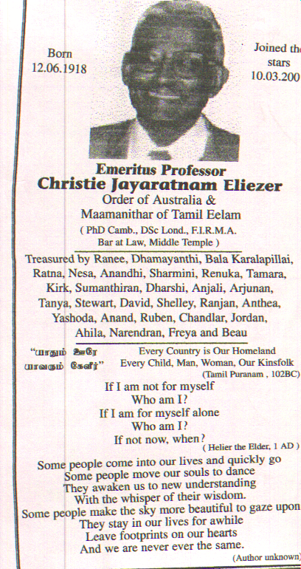

Editorial

Among the major schools of the North of the Sri Lanka, Hartley college was the most unfortunate, in that it suffered the heaviest damage. In addition the college had to find accommodation in other schools and was like an orphan. We congratulate the Principal the late Mr. Nadarajah for bringing it back to its old premises but had to be contended with make shift arrangements for roofing and class rooms and other basic facilities, since armed forces were occupying part of the building . Even at this moment it is being partly occupied and the present truce is expected to get them move out. The Laboratory block is without roof and on the top of it there has been frequent changes in staff and principal. We heard that Kanapathipillai house which has been in existence for more than fifty years has been replaced with Pooranampillai house. There are various requests for help to the branches some overlapping.
It is in this crucial crossroad of the college that the Canada branch floated the idea of a joint meeting of all PPA branches of Hartley this year around July or August to deliberate as to how we can help towards salvaging what is left of this famous land mark college that has served the Vadamaradchy students for many generations and that had made them to shine all over the world. This idea was supported by the UK branch and together we approached other branches and happily all branches have agreed to participate under the auspices of Colombo branch along with the Principal and parent body.
Let us all pray that this meeting will find some relief to the many problems that the College has for getting back on its feet. This is a duty that we all owe for our Alma mater

M.Atputhanathan
Editor

(apologies for any inadvertent mistakes)

